Computer Wi-Fi Set Up
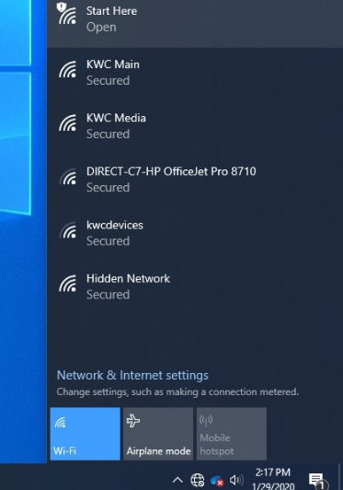
Step 1. Go to Wi-Fi and select “start here”

Step 2. If your internet browser doesn’t open automatically go to “onboard.kwc.edu”

Step 3. Select start.
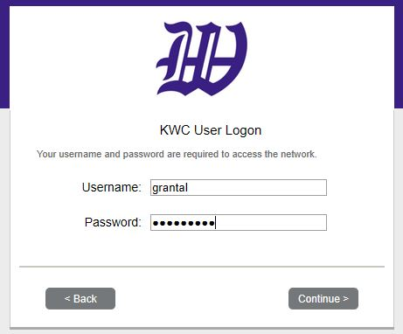
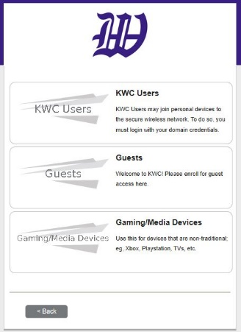
Step 4. Select “KWC User” and Sign in with KWC username and password.

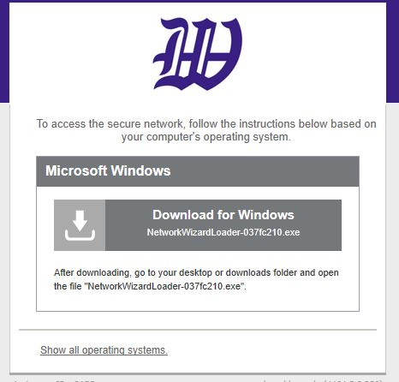
Step 5. Download it from windows and select “RUN”

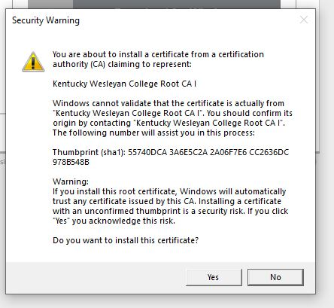
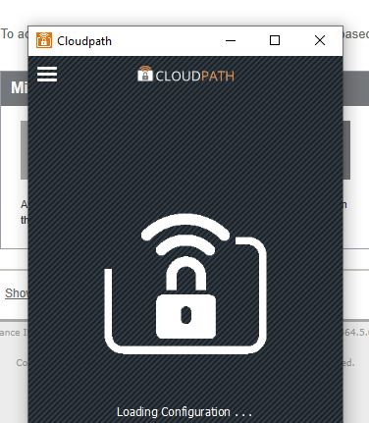
Step 7. Cloud path and a security warning will pop up. Select yes on the security.

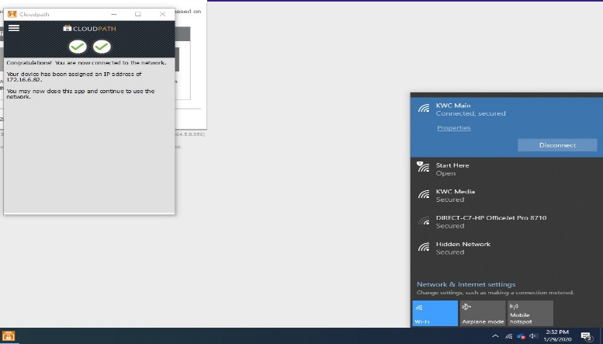
Step 8. Your Internet should connect and you will see 2 green check marks. In your Wi-Fi selection you will see it has been connected to KWC Main

If you were not able to connect please submit a help desk ticket at kwc.edu/help

