HOW TO UPDATE YOUR MACHINE?
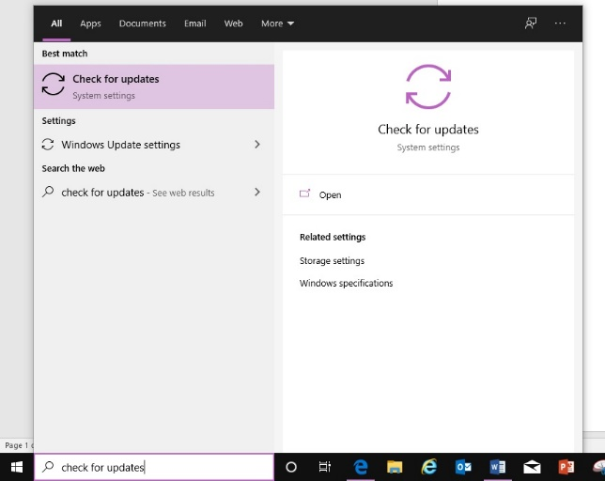
- Step 1) Go to the search bar on the bottom left corner and type “check for updates” and select “check for updates”.

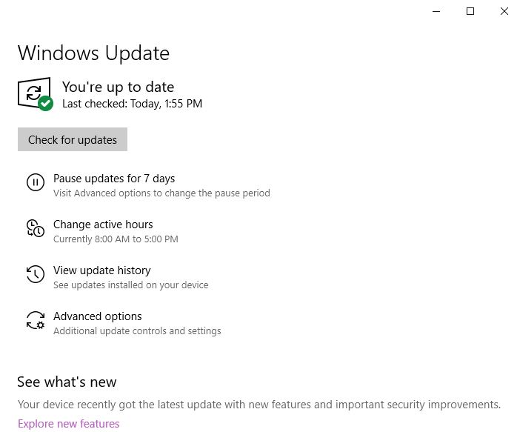
- Step 2) Select check for updates. It will update to see if you have any updates available. If you have updates push the updates through. Once finished, it will ask you to restart your machine.

- Step 3) Once your computer has restarted, repeat step 1 and 2 to confirm your machine is up to date.

